Lesson plan

Topic Using the gym
Level: Entry 1 - Entry 3, Scottish National 1 – 4

Time: Approx. 90 minutes

Aims: to help learners recognise and use common gym-related terminology and to talk to gym staff about their exercise preferences and aims.

Objectives
Learners will be able to:
- recognise the names of five different health checks used in the gym
- recognise and use gym related vocabulary for types of exercise
- recognise and use the names of five pieces of common gym equipment
- talk about their use of the gym and fitness aims

Introduction
This lesson is about using the gym. It provides students with the vocabulary and speaking practice to feel more confident in understanding and talking to gym staff and users about gym equipment and exercise.
The audio files can be accessed from http://…etc

You will need:
- Resource 1 – one copy per learner
- Resource 2 – one copy per learner
- Resource 3 – one copy per learner
- Resource 4 – role play cards, cut up
- Audio A (gym induction) and B (advice) and a device to play them
- Audio b transcript – one copy per learner (extension/homework)

Procedure

Warmer (5 minutes)
- Show learners the pictures on a copy of resource 2 (fold over the words).Elicit what they think the lesson might be about.
- Write the following questions on the board with gaps. Elicit how to complete the questions in a suitable way:
1. How often ……….............gym?
2. Why do/don’t ……………gym?
3. What do ………………….in the gym?
- In pairs, learners should ask each other about their exercise habits using the questions. Pair learners of similar oral ability.
- Ask them to briefly feed back to the class about their partner.

Activity 1 – Listening to an induction assessment (15 minutes)
- Elicit the name of the short interview new gym users often have. (induction assessment )
- Find out who in the class has had an assessment in the prison gym or previously. Elicit briefly what happens. Confirm that it is a set of short health tests.
- Look at the five pictures on resource 1. Elicit which picture shows the heart rate test.(4) Write the word on the board for the learners to copy down in part A. Follow the same procedure for all the other pictures. Clarify meanings where necessary. (See answers)
- Play audio recording 1 about a gym induction assessment. In resource 1 part B learners should listen and number the five health checks in the order they appear in the dialogue.
- Ask learners to listen again and write down the results of the test next to the word.

Differentiation: Lower-level learners can focus on ordering the five health checks only.

Activity 2 – Gym equipment vocabulary (20 minutes)

- Before handing out resource 2, ask learners to recall any of the pictures of common pieces of gym equipment they saw on the sheet in the warmer activity.
- Show resource 2. Drill the five vocabulary items.
- Write the words resistance exercise and cardio exercise on the board. Say one means exercise that makes the heart beat fast and one means building muscle. Ask them to guess which is which. (see answers)
- Then ask learners to decide which piece of equipment is good for cardio and which for resistance. Write the five vocabulary items as a list correctly under each heading on the board. Learners can copy onto resource 2. (see answers)
- Ask less confident learners to practise reading and spelling the seven words aloud in pairs by looking at and saying the word, then covering and writing it and then checking.
- Look at the final part of resource 2. Ask how many learners use dumbbells (pictured). Look at the excerpt from a fitness programme. Ask if anyone knows what is meant by sets and reps. Ask the learners to choose which definition matches which word.(see answers)
- In pairs or small groups, give learners extended time to talk about what types of exercise and pieces of equipment they use to exercise now or in the past and why. Elicit a range of sentence starters and language first to guide learners into possible structures to use for the activity, e.g. Entry 2/3 I went to.., I used to (use).., …better than…, more well-equipped than.., E1 My favourite equipment/exercise is.., I prefer…,

Differentiation:
- Lower-level learners practise reading and spelling the new words aloud
- Higher-level learners add any other pieces of equipment or types of exercise they know that are good for both forms of exercise and extend the lists. (see answers for suggestions)

Activity 3 – Reasons for using the gym (25 minutes)
  - Start by asking those who use the gym why they go and what their aims are. Write them on the board.
  - Focus the learners’ attention on the speech bubbles on resource 3 which show possible aims for using the gym. Look at the words and definitions below. Ask learners to match the meanings of the aims with their definition. Pair up more and less confident readers. (see answers)
  - Correct answers. Drill the phrases in the six speech bubbles.
  - Discuss which of the learners’ aims are similar to those shown in the speech bubbles.
  - Put learners in pairs. Assign a different speech bubble aim to each pair. Ask them to think what exercise and equipment they would advise that gym user to use. Feed back to the group.
  - Ask learners to listen to audio recording B and complete the chart with what the gym instructor advises them to do. Play as often as required.
  - Confirm answers and discuss any issues arising.

Differentiation:
- Lower-level learners can use resource 2 for help with spellings and note down only the pieces of equipment mentioned.
- Higher-level learners can practise asking each other additional questions using comparatives. How can I get fitter/thinner/stronger/more toned?

Activity 4 – Gym role play (15 minutes)
- Focus the learners’ attention on resource 3. These are some questions that a fitness instructor might ask a gym user. Check meanings are known. Ask learners to practise saying them aloud.
- Model the role play with a confident learner. Play the role of the instructor. Encourage the learner to give their own answers using vocabulary from the lesson so far and training aims from the previous activity.
- Put the learners in pairs to do the role play, swapping over roles. If learners would benefit from a more structured role play, use resource 4 cards.

Differentiation:
- While some learners practise saying the questions, ask stronger learners to write two or three more questions they could ask a gym user in the role play.
- Less confident learners could ask only two or three questions.

Cooler Vocabulary recap (10 minutes)
- Put learners into pairs or small groups. Mix different levels of learner, if possible. Ask them to turn over all the resources from the lesson.
- Ask the following quiz questions:
a) write down one list of cardio and one list of resistance exercises or equipment. (a point for each appropriate item in the correct list)
b) write down five reasons for wanting to use the gym.(one point for each answer)
c) name the five health tests.(one point for each answer)

Extension activities / Homework
- Go to the gym and find out the names of at least 5 more pieces of equipment.
- Rewrite the instructor’s role in Audio B transcript giving different suggestions for exercises.
- Read a new role play aloud with a partner.

Transcripts

Audio A
Instructor: We need to do a few tests with you just to check your general health before you start using the gym, OK?
First I’ll just check your blood pressure.
Right , that’s normal 120/80.
And now your resting heart rate. OK.
So, your resting heart rate is 70 bpm.
Now just stand over here and I’ll measure your height. 170cm. That’s great.
And now your weight. Just stand on the scales. Fine. that’s 80kg.
And finally your body fat percentage. Just wait a minute. Right that’s 18%.
Well, that’s all the tests done and there’s no problem with you using the gym.

Audio B
User: How can I lose weight?
Instructor: Run for 20 minutes on the treadmill every day.
User: I want to get fitter.
Instructor: Do 20 minutes fast cardio on the cross-trainer every day.
User: I want to tone up
Instructor: Do barbell and dumbbell exercises. 15 reps.
User: How can I bulk up?
Instructor: Do barbell and dumbbell exercises. 4 sets of 10 reps.
User: I want a six-pack
Instructor: Do 30 minutes fast cardio on the rower.

Resource 1 Vocabulary and listening
A
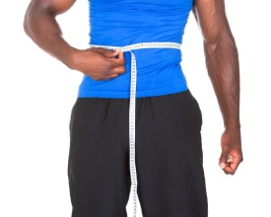 | 1.
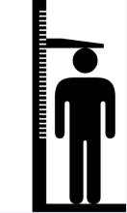 | 2.
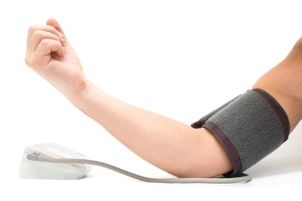 | 3.
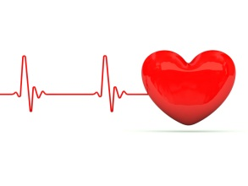 | 4.
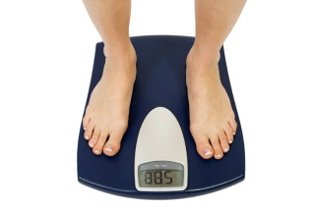 | 5.
B
height  ……………………………………………………………………………………
weight  ……………………………………………………………………………………

blood pressure  ……………………………………………………………………………..
heart rate  ……………………………………………………………………………

body fat percentage  ……………………………………………………………………

Resource 2 Vocabulary
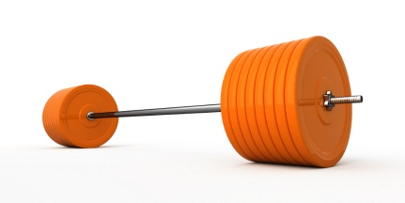 |  | barbell
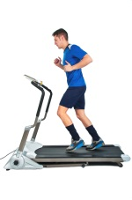 |  | treadmill
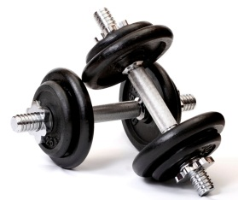 |  | dumbbells
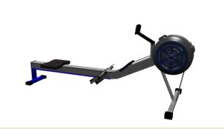 |  | rower
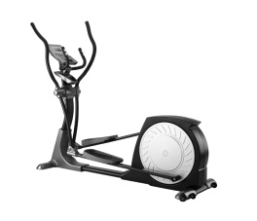 |  | cross-trainer
resistance cardio
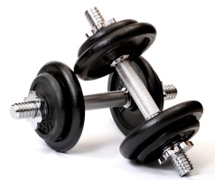 | Programme  Dumbbell lifts. Do 3 sets of 10 reps. |  | do ten lifts  do the ten lifts three times

Resource 3 Listening and speaking
Equipment? How long? How often?
How can I lose weight? |  | 1. …………………………………………..
I want to get fitter. |  | 2. …………………………………………..
I want to tone up. |  | 3. …………………………………………..
How can I bulk up? |  | 4. …………………………………………..
I want a six-pack. |  | 5. …………………………………………..
aims |  |  | meanings
1. lose weight  2. get fitter  3. tone up | 4. bulk up  5. a six-pack |  | a) very big muscles all over (men)  b) strong stomach muscles (men) | c) be slimmer  d) stronger muscles  e) have a healthy body
Fitness instructor
1. Why do you want to use the gym? …………………………………………………
2. Do you prefer cardio or resistance exercise?.........................................................
3. What equipment have you used before? ……………………………………………
4. What health tests have you had before? ……………………………………………
Resource 4 Cue cards to answer four role play questions
1. lose weight  cardio  treadmill, rower  blood pressure, weight | 2. bulk up  resistance  barbells, dumbbells  heart rate, weight
3. tone up  resistance  cross-trainer, dumbbells  height, weight | 4. a six pack  resistance and cardio  rower, barbells  body fat percentage
5. get fitter  cardio  cross-trainer, treadmill  blood pressure | 6. lose weight  cardio  cross-trainer, dumbbells  body fat percentage
7. tone up  cardio  rower  blood pressure | 8. get fitter  cardio  rower  height, heart rate

Suggested answers:

Resource 1
Part A | Part B
1. body fat percentage test | 5 (18%)
2. height | 3 (170cm)
3. blood pressure check | 1 (120/80)
4. resting heart rate | 2 (70bpm)
5. weight | 4 (80kg)

Resource 2
a) resistance exercise – building/toning muscle / cardio exercise – makes the heart beat fast
b) cardio – cross-trainer, rower, treadmill / resistance – dumbbell, barbell
c) sets – do the ten (lifts) three times / reps – do ten (lifts)
Differentiation:
resistance: e.g. sit-ups, pull-ups, press-ups, the plank
cardio: e.g. running, boxing, exercise bike, zumba, spinning

Resource 3 Vocabulary
Equipment | How long? How often?
- treadmill | 20 minutes
- cross-trainer | 20 minutes
- barbell and dumbbell | 15 reps each
- barbell and dumbbell | 4 sets of 10 reps
- rower | 30 minutes
aim | meaning
1. lose weight | c) be slimmer
2. get fitter | e) have a healthy body
3. tone up | d) stronger muscles
4. bulk up | a) very big muscles all over
5. a six-pack | b) strong stomach muscles

